**8-2 REGRESSION ANALYSIS**

**PRIYANKA AMULYA CHUKKAPALLI**

**SOUTHERN NEW HAMPSHIRE UNIVERSITY**

**MANAGEMENT SPREADSHEETS/SCIENCE**

**PROFESSOR: D. BUTLER**

**PROBLEM**

The IRS wants to develop a method for detecting whether individuals have overstated their deductions for charitable contributions on their tax returns. To assist in this effort, the IRS supplied data found in the file Dat9-7.xls on your data disk listing the adjusted gross income (AGI) and charitable contributions for 11 taxpayers whose returns were audited and found to be correct.

a. Prepare a scatter plot of the data. Does there appear to be a linear relationship between these variables?

b. Develop a simple linear regression model that can be used to predict the level of charitable contributions from a return’s AGI. What is the estimated regression equation?

c. Interpret the value of R2.

d. How might the IRS use the regression results to identify returns with unusually high charitable contributions?

**SOLUTION:**

A. We should follow the steps shown to make a scatter plot from the data we have.

The next step is to select the scatter plot from the insert menu.

Now we will get a graph like this:

If we want, we can label it. According to this graph, there appears to be a positive linear relationship between charitable contributions and AGI and charitable contributions rise in tandem with an increase in adjusted gross income.

A. To perform regression analysis, ensure that the analysis tool Pak add-in is enabled; if not, navigate to File > More > Options. After selecting add-ins, select go. A window will now appear from which we can activate Tool Pak. Check the choice with the examination instrument Pak and hit all right.

After that, select data analysis from the data menu, select regression from the window tab and then click OK. The screenshot below depicts the steps:

We will see a window where we can drag the data to select the X- and Y-ranges. Choose a 95% confidence level for the option. Now, select OK.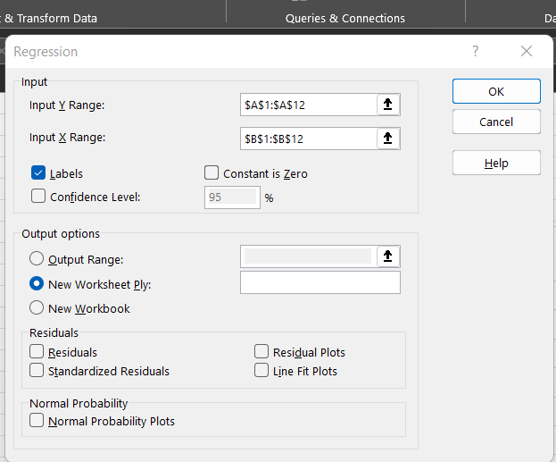

Now click on OK and the result will exist in the new worksheet.

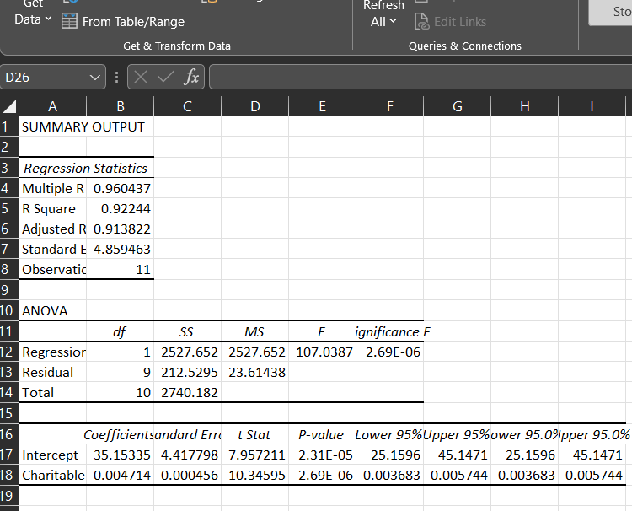 The estimated regression equation is written as follows in the output:

A. The R-square, also known as the coefficient of determination, indicates the proportion of the total variation that is explained by the regression line. Charitable Contributions = -6169.94+195.69(AGI). The R-square value is 0.922, according to part(b) output, which is 92.24%of the variety accordingly factor is made sense of by logical variable in the relapse condition and the rest 7.7%of the variety stays unexplained. The IRS uses a confidence interval for the mean level of charitable contributions for a given level of AGI in order to identify returns with unusually high charitable contributions. Returns with high charitable contributions can be identified if the upper level of the confidence interval is exceeded.(T.Ragsdale, 2007)

# References

T.Ragsdale. (2007). *Spreadsheet Modeling and Decision Analysis.* Virginia: Thomson.